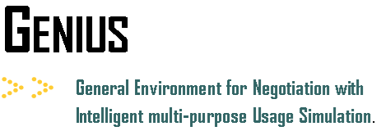

**Quick Start Tutorial: How to run a Negotiation session**

In this tutorial you will learn how to run a negotiation session. A negotiation session is a single negotiation in which two agents compete. This mode is mainly intended for new users.

There are two types of agents that can be used in a tournament:

* **Automated agents** – agents that can compete against other agents in a negotiation without relying on input from a user.
* **Non-automated agents** – agents that are fully controlled by the user. These types of agents ask the user each round which action they should make (UIAgent).

Select “**Start**” and then “**Negotiation Session**”. This opens a window similar to the figure below.

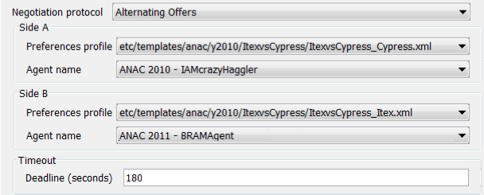

The following parameters need to be specified to run a negotiation:

* **Negotiation protocol** – the set of available protocols (“Alternating Offers” is often used)
* **Side A/Side B** – the configuration of the agents on both sides
* **Preference profile** -the preference profile to be used by the agent of that side.
* **Agent name** – the agent participating in the negotiation
* **Deadline (seconds)** - the length of the negotiation in seconds

Select **“Start”** to begin the negotiation session.